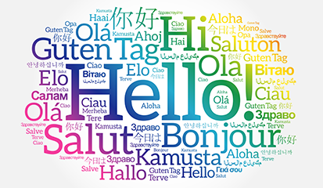
ALNS Languages Department: Curriculum Intent and Implementation
2026-27
a
CURRICULUM INTENT
At ALNS, we believe that language learning opens doors to other cultures, broadens horizons and develops students into confident global citizens. We want all students to develop the knowledge, skills and cultural awareness necessary to communicate effectively, think critically about language and culture, and appreciate the value of languages in an increasingly interconnected world.
We want to equip our students with the knowledge and skills to thrive and success in language learning by:
- Encouraging and inspiring them with quality-first teaching.
- Broadening their awareness of other countries, traditions, and communities.
- Providing opportunities for participation in a broad range of linguistic and cultural educational experiences.
- Encouraging students to be able to use transferable skills: skills that can be utilised in other lessons across the curriculum.
- Enriching students’ experience of Languages by incorporating a diverse range of authentic material such as videos, blogs, and newspaper/magazine articles etc.
- Providing a clear sense of purpose to tasks, making them ‘real’ and relevant to everyday life.
- Encouraging students to take ownership of their own revision materials and strategies at Key Stage 4.

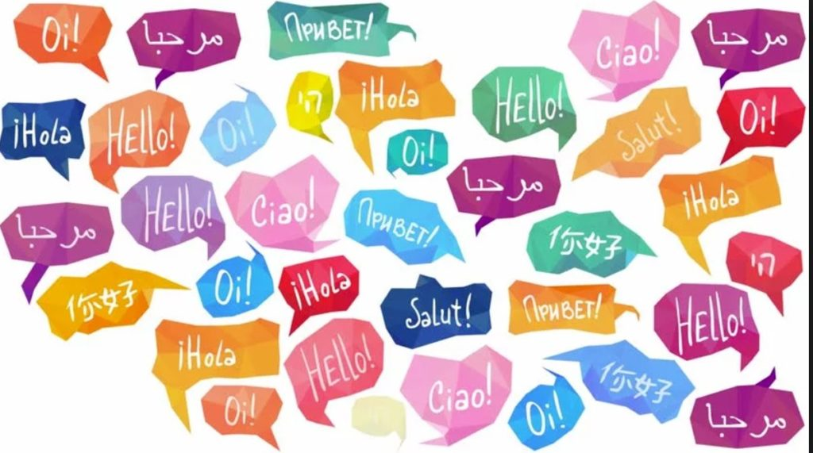
Our principles behind our approach to Languages lessons:
We want to equip our students with the knowledge and skills to thrive and success in language learning by:
- Encouraging and inspiring them with quality-first teaching.
- Broadening their awareness of other countries, traditions, and communities.
- Providing opportunities for participation in a broad range of linguistic and cultural educational experiences.
- Encouraging students to be able to use transferable skills: skills that can be utilised in other lessons across the curriculum.
- Providing a clear sense of purpose to tasks, making them ‘real’ and relevant to everyday life.
- Encouraging students to take ownership of their own revision materials and strategies at Key Stage 4.
We want our students to:
- use language skills, receptively and productively, for communication in the real world, for practical purposes, for their immediate needs, interests and beyond and to express and justify opinions.
- develop their confidence and autonomy to access new and unfamiliar language through the use of decoding skills brought about by the explicit teaching of phonics and sound patterns.
- work towards becoming a fluent and spontaneous speaker of the foreign language.

CURRICULUM DESIGN AND SEQUENCING
The aim of the languages department is that all our language learners develop into confident and articulate “world citizens” who consider themselves a part of a multicultural and mutually respectful society. We seek to ensure that all our students acquire the educational and cultural capital to which all children are entitled. It is our goal to ensure that our curriculum is challenging and inspiring for all. We want our students to have a love of languages and culture and make sure they realise the endless possibilities and opportunities that having a second language can bring.
The Languages curriculum is designed as a carefully sequenced five-year spiral curriculum in which vocabulary, phonics, grammar, cultural knowledge and communication skills are revisited and developed in increasingly challenging contexts.
In Years 7 and 8, students follow the Gianfranco Conti Extensive Processing Instruction (EPI) approach. Learning is centred around carefully planned Sentence Builders which provide students with the vocabulary, grammar and structures required to communicate confidently in the target language.
From Year 9 onwards, students transition towards a hybrid curriculum model. Whilst Sentence Builders continue to underpin language acquisition, increasing emphasis is placed upon GCSE vocabulary acquisition, exam strategy, authentic materials, extended writing, spontaneous speaking and GCSE-style assessment tasks.
TEACHING AND LEARNING
Key pedagogical approaches include retrieval practice, spaced learning, flipped learning, explicit instruction, modelling, scaffolding, glossary building, oracy and technology-enhanced learning. Teachers regularly model pronunciation, translation skills, writing structures, speaking responses and GCSE exam strategies.
How is the curriculum delivered/taught?
Key Pedagogies
To maximise our students’ progress, we utilise a variety of pedagogical approaches when delivering languages lessons, namely:
- Knowledge retrieval
Regular and spaced recycling and retrieval of high frequency vocabulary, verbs and structures across as many modalities as possible supports the storing of knowledge in the long term
memory.

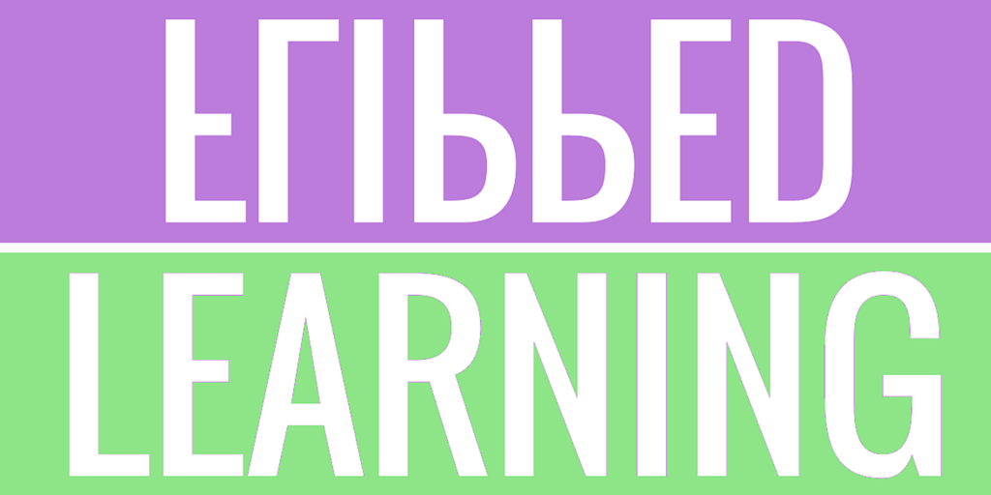
- Flipped learning
Flipped Learning puts greater focus on the pre-learning which takes place prior to the lesson so that the lesson can focus on applying the knowledge. Flipped Learning creates opportunities with students’ independent learning before their lesson. It requires careful planning to ensure that the learning/application in the lesson builds on the learning that has taken place prior to the lesson.
- Spaced learning
We endeavour to revisit and review vocabulary, grammar and assessment foci across both Key Stages in the following way:
- Sentence Builders build on previous knowledge whilst incorporating new vocabulary and structures.
- The RAINBOW template is used in every topic to structure spontaneous writing tasks.
- Independent Learning is used cyclically and revisits vocabulary from previous topics.

- Oracy
This lies at the very heart of language-learning and students are encouraged to not only speak in the foreign language but also articulate their learning and thinking behind it.
- Modelling of exam strategy and exemplar answers
Having teachers complete answers to tasks whilst talking students through the thought process involved helps to break down the task into more manageable sections. Additionally, this approach helps to build student confidence when facing exam questions.
- Scaffolding
This progressively moves students towards greater independence and understanding during the learning process. Like how builders require scaffolding to access new heights, instructional scaffolding helps student navigate exams and accomplish tasks they otherwise might not have been able to.

- Building glossaries
Students are encouraged to build their own glossaries of key vocabulary for future retrieval and revision. Frequent reminders from teachers to revisit the glossary vocabulary will help to commit to the long-term memory.
- Use of Technology such as Kahoot, Quizlet, Kerboodle, LanguageNut and Blooket
Technology offers the flexibility to use a combination of tools and methods to help students absorb new information and efficiently learn and enhances the language learning process. Using technology creates an interactive learning environment and transforms students from passive recipients to active learners and allows more profound and enriching linguistic immersion.
Through our Schemes of Learning the four inherent skills of a language encompass the following acquisition:
Reading:
Students learn to:
- deepen their knowledge about how language works and enrich their vocabulary in order for them to increase their independent use and understanding of extended language in a wide range of contexts
- develop awareness and understanding of the culture and identity of the countries and communities where the language is spoken
- be encouraged to make appropriate links to other areas of the curriculum to enable bilingual and deeper learning, where the language may become a medium for constructing and applying knowledge
- develop language learning skills both for immediate use and to prepare them for further language study and use in school, higher education or in employment.

Writing
Students are empowered to:
- acquire new knowledge, skills and ways of thinking through the ability to understand and respond to a rich range of written material
- use structure and grammatical features ambitiously to give their writing cohesion and coherence
- convey clear meaning using the target language appropriately
- use grammar correctly, punctuate and spell accurately
- acquire and apply a wide general and subject specific vocabulary, alongside a knowledge and understanding of grammatical terminology in their own language and the target language.

Speaking and Listening
Students are encouraged to:
- develop their ability to communicate confidently and coherently with teachers in speech, conveying what they want to say with increasing accuracy
- express and develop thoughts and ideas spontaneously and fluently
- listen to and understand clearly articulated, standard speech at near or normal speed
- deepen their knowledge about how language works and enrich their vocabulary in order for them to increase their independent use and understanding of extended language in a wide range of contexts
- acquire new knowledge, skills, and ways of thinking through the ability to understand and respond to a rich range of authentic spoken material
- respond perceptively to questions and feedback

A range of activities and styles are used so that appropriate interactive tasks and games are built into the learning sequence so that students can manipulate vocabulary and structures to help them understand and embed them into their long-term memory.
There is a focus on excellent questioning which is a valuable strategy used to assess comprehension within the lesson to ensure understanding and to create challenge.
Students are issued with “Personalised Learning Checklists” (PLC’s) following key exams so that they can self-identify areas of weakness and focus their revision efforts accordingly. In addition, thorough question level analysis of all assessments allows for identification of gaps in both knowledge and skill. Teachers will also review the analysis and teach subsequent lessons accordingly to address any gaps or misconceptions in the learning.

In order to aid memorisation, vocabulary is constantly revisited through increasingly complex grammatical structures. Furthermore, the use of visual and audio prompts as well as games and competitions helps to build connections and embed vocabulary into the long-term memory. To build on cultural capital, lessons often draw inspiration from the life experiences of teachers.
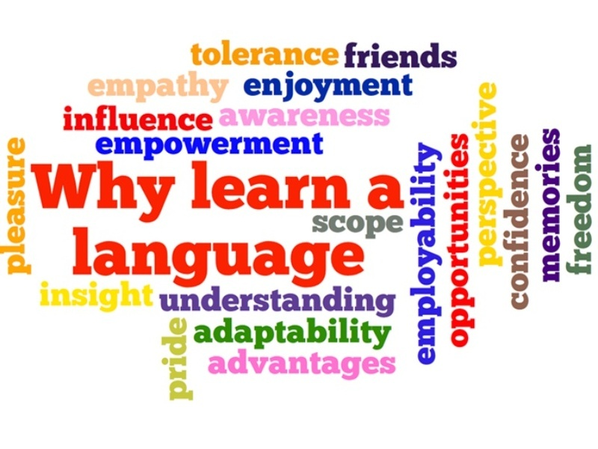
After a key piece of work, students are given constructive feedback which allows them to be successful but also focuses on their next steps. Following on from assessment feedback, students are then given time within lessons to reflect on their feedback and to act upon it. Errors in student work are very rarely corrected, but are simply highlighted. Students have to think hard about their errors in order to correct them themselves. In order to achieve this, students are issued with a “common mistakes” sheet on which there will be ten to twelve common mistakes which the class has made in that particular piece of work. This is gone through with the class as a whole who then record the correct sentences. These corrected sentences can then be referred to by the students so they can identify and then correct their own errors.
The importance of languages in our modern society is constantly growing, and teachers will take every appropriate moment in lessons to stress the value of having a GCSE in a foreign language for future education and career opportunities. Having a qualification in languages on a CV is incredibly useful and teachers endeavour to get this message across to our students as frequently as possible. Exploring the possibilities of future occupations which involve languages will often take place in class discussions, so students see the real benefits of being able to speak another language.

HOW DO WE DEVELOP CULTURL CAPITAL?
At ALNS, we believe that language learning plays a vital role in developing students' cultural capital by broadening their understanding of the wider world and helping them appreciate different cultures, traditions and perspectives. We are committed to ensuring that all students, particularly those from disadvantaged backgrounds, have access to experiences that enhance their aspirations and prepare them for future study, employment and global citizenship.
Languages are studied by all students at Key Stage 3 and by the vast majority at Key Stage 4, reflecting our belief that linguistic skills are increasingly valuable in today's interconnected world. To bring language learning to life and provide authentic contexts for communication, students have opportunities to participate in educational visits to Caen and Aachen, where they can experience the language and culture first-hand.
In addition, Year 10 students take part in a Personal Development Day focused on New Technology, which enables them to apply their language skills across all four disciplines of listening, speaking, reading and writing whilst exploring contemporary global issues.
Teachers regularly draw upon their own experiences of living, studying and working abroad, as well as a range of authentic cultural materials, to enrich lessons and inspire students. Through these experiences, students develop a greater understanding of the opportunities that language learning can provide and gain the confidence to see themselves as active participants in an increasingly diverse and interconnected world.

LITERACY ACROSS THE CURRICULUM
Literacy is central to language learning and is explicitly developed through reading, writing, oracy and vocabulary acquisition. Following curriculum review findings, the department has strengthened its disciplinary literacy approach to ensure students can communicate accurately, confidently and independently in the target language.
Reading
Students are taught to read like linguists by decoding unfamiliar language, recognising grammatical patterns, identifying cognates and using context to infer meaning. Explicit phonics instruction and active reading strategies help students access increasingly complex texts and GCSE-style materials with confidence.
Writing
Students develop their writing from accurate sentences to extended GCSE-style responses through the use of Sentence Builders, RAINBOW Templates, modelling and structured practice. Teachers explicitly teach grammar, vocabulary and linguistic accuracy whilst promoting increasingly ambitious and independent writing.
Oracy
Oracy is embedded within every lesson. Students regularly rehearse language aloud, develop pronunciation and phonics awareness, and use the target language through structured speaking activities. Techniques such as Cold Call, Turn and Talk and Stretch It ensure high levels of participation and challenge.
Vocabulary Development
Vocabulary is explicitly taught, regularly retrieved and systematically revisited across all four skill areas. Through Sentence Builders, Verb Bubbles, glossaries, Independent Learning and retrieval activities, students develop the vocabulary knowledge required to communicate effectively and access increasingly challenging language.
ASSESSMENT AND FEEDBACK
Students complete mid-topic assessments, end-of-topic assessments and GCSE-style assessments. Results are recorded by both teachers and students using assessment trackers. Question-level analysis informs curriculum adaptation, intervention and responsive teaching.
Assessments will take place at the end of every topic and are based around the three skills of listening, reading and writing. Assessments are based on real GCSE tests and try to mimic these as far as possible, using real GCSE questions as well as specimen questions.
Although assessments are topic-based, KS4 assessments include at least 1 question from previously learnt topics to ensure students retain vocabulary using the spaced learning approach. In addition, assessments include a variety of question styles to ensure that students are not only being tested on topic vocabulary but also on their exam strategy.
Assessment results are recorded by both teachers and students to track progress. Students record results of listening and reading activities in their assessment grids, which are kept in the front of their books. Referring to the assessment grids on a frequent basis allows students to track their progress effectively and pinpoint which skills or topics they need to focus their efforts on.
Teachers register marks from assessments and terminal exams on a DATA tracker which automatically works out the grade and whether the student is on, above or working towards target, according to their expected grade.
Having students engage on a regular basis with their trackers in KS3 and the AQA GCSE mark schemes and grade criteria at KS4, they are able to develop a good understanding of what is required of them at each stage of their language learning journey to reach their expected target grade and beyond. The interlinked use of both self- and peer-assessment is routine in languages lessons helps students to connect successfully with the criteria.
To further students’ understanding of the exam grade criteria, an RMI (Review, Mark, Improve) sheet is sometimes implemented, following a writing task. This allows students to play the role of the teacher by reviewing an example piece of work by a student, correcting, then marking it according to the grade criteria and then, finally, improving it.
Question level analysis following the assessments informs the subsequent planning of lessons which follows, allowing for any gaps in knowledge to be addressed.

PEER ASSESSMENT
Peer assessment follows the whole-school framework: understanding success criteria, teacher modelling, structured WWW and EBI feedback, and dedicated improvement time. Students utilise mark schemes and success criteria to evaluate and improve work. This is exemplified in the model below:
Clear → Modelled → Structured → Improved
Stage | What the Teacher Does | What the Students Do | Key Questions | Non-Negotiables
1. Understand Success Criteria | - Share learning objective  - Share success criteria / mark scheme  - Discuss what strong work looks like  - Model how criteria apply | - Read and understand success criteria  - Identify what good work looks like | - What am I looking for?  - What does success look like? | - Success criteria always shared  - Students understand expectations before starting
2. Model the Process | - Use visualiser to model peer assessment  - Read an example response  - Highlight strengths  - Identify improvements  - Demonstrate good feedback | - Observe and listen - Follow teacher thinking  - Ask questions if unsure | - How do I assess work?  - What does good feedback look like? | - Teacher modelling is explicit  - Visualiser used where possible
3. Structured Peer Feedback | - Provide clear structure (WWW/EBI, checklist, mark scheme)  - Guide students to link feedback to criteria | - Assess peer work  - Identify strengths (WWW)  - Suggest improvements (EBI)  - Use subject-specific criteria | - What has been done well?  - How can this improve? | - Feedback must be specific  - Linked to success criteria  - No vague comments
4. Improve the Work | - Build time into lesson for improvement  - Direct students to act on feedback | - Edit or redraft work  - Correct errors  - Improve responses  - Show progress | - How can I improve my work?  - What will I change? | - Time for improvement is essential  - Students must act on feedback

An example of peer-assessment is below:
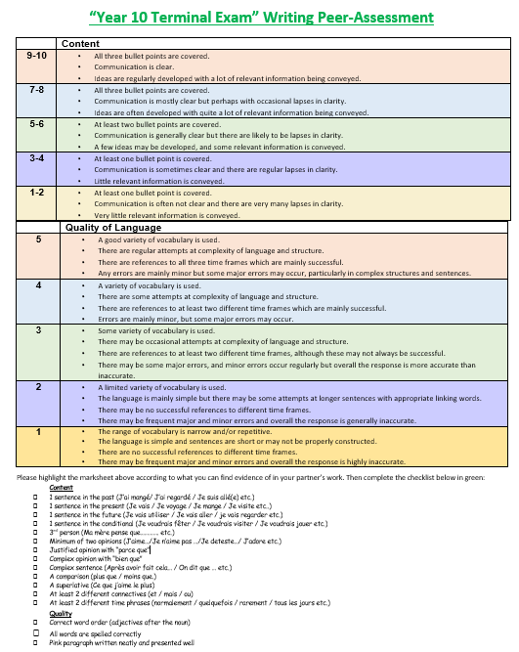

ALNS Languages Assessment and Marking Policy
Teacher Feedback | Students Taking Next Steps | Peer or Self-Assessment
Mark books following a key piece of work using purple pens. | Students use pink pen to take their next steps and feed forward. | Students use green pen to peer and self-assess
Only focus on one piece of work to mark. For example, a written paragraph, speaking preparation or an exam question. | After marking always allow time in next lesson for students to take their next steps | There should be an opportunity for self or peer assessment in most lessons
Use a “Next Step Sticker” to outline what went well and how the student can make further progress from their piece of work. | Students answer any questions you have asked them on the content | When marking a specific piece of work, students can write a “What went well” comment and an “even better if comment” under their peers or their own work
Feedback on the sticker should be specific. For example, a next step could be “include a 3rd person past tense sentence” or “You need to justify your opinions by giving reasons” | Students take their next steps outlined in feedback sticker. This can be done by rewriting part of their answer using your advice. | Students WWW and EBI comments should be skill specific and should help the peer/themselves progress
Feedback should allow students to show progress by responding to your feedback | Once improved, use “Learning Objective Achieved” stamp to acknowledge improvement. | As often as possible, students use GCSE Criteria to mark a piece of work and use checklists for WWW and EBI comments
Where appropriate use GCSE criteria as a guidance for feedback given on marking stickers | If necessary give further verbal/written feedback so that answer can progress even more | Students should complete “next steps” in their assessment grid at the front of their books.
Develop student’s knowledge of content by asking questions within their piece of work (not on sticker). This can be used to clarify a misunderstood point or extend their knowledge. E.g Why is there a capital on the word “Stadt”? or How could you extend this sentence using a modal verb? | After marking always allow time in next lesson for students to take their next steps
Mark SPAG using the SPAG marking code (students also use this to peer mark SPAG). |  | SPAG Code.  - Underline and write ‘sp’ when there is a spelling error  - //NP for a new paragraph  - G for grammatical errors  - ~~ to show a grammatical error  - P for punctuation-circle the incorrect letter

Languages Department Assessment Flowchart
Students complete a piece of writing and proof-read it according to criteria you give them
Using school stickers (or languages marksheets), write/tick two phrases for www Give/highlight two targets based on GCSE markschemes for ebi

Students are awarded with a GCSE grade or AOB grade either through self-assessment/peer-assessment or through you as the teacher (using a markscheme or teacher-set criteria)

Students swap books and complete peer-assessment in green using www and ebi

Students complete self-assessment in green using www and ebi

Students rewrite out their entire paragraph in pink, inserting their correct target sentences where appropriate to improve their work as an overall piece

Stamp their work to say whether the targets have been achieved or not

Highlight the word/structure the student needed to include to achieve their target

Check student target responses and point out errors
Students respond to targets by writing one sentence per target you have given them in black/blue pen

Students answer questions you have asked in pink

Ask students questions about their mistakes so they have to think through their response carefully (OPTIONAL)

Do not correct errors. Simply highlight and use SPAG abbreviations accordingly

Students hand in books and you mark them in purple, starting with PPG students first

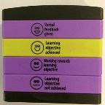

Anticipating common errors and misconceptions
- As you mark your students’ work, make a note of key errors.

- When finished, look through the list of errors made by students and choose your most frequent.

- Only highlight errors on student work – do not correct them.

- Produce a “common mistakes sheet” with these most frequent errors.

- Hand this sheet out at the start of the next lesson and talk students through each one without telling them what the mistake is.

- Students have to work together to ascertain what the mistake is in each one.

7. Go through all of the common mistakes and ensure students have full, corrected versions on their sheet.

- Hand back assessment with highlighted errors.

- Students have to use the “common mistakes sheet” to help them correct their own errors in pink.

- Ensure students show you their corrected mistakes for accuracy.

11. Students re-write out their work in pink, with their accurate corrections.

- Get students to refer to their work and “common mistakes sheet” before they start their next piece of work so they can avoid making the same mistakes again.

Using Marking Stickers
The marking stickers are used to mark one piece of writing work only. Students are given an Attitude to Learning grade and an AOW based on that one piece of work. The WWW section and Next step section should be completed with a specific target to improve work. The next steps need to allow students to respond. Once books have been handed back to students, they then respond to feedback in pink pen.
See below for some examples of this in practice:
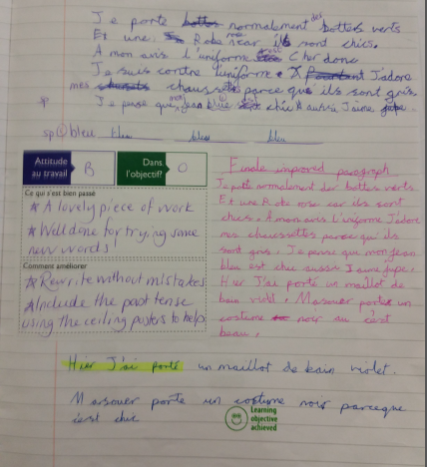
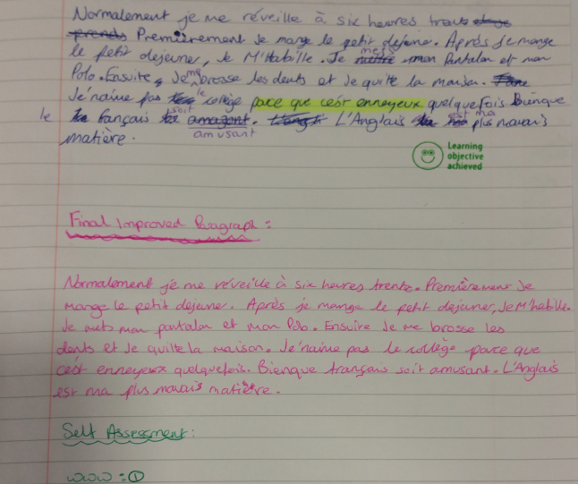

INDEPENDENT LEARNING
Independent Learning is an integral part of the Languages curriculum and is designed to strengthen vocabulary acquisition, reinforce classroom learning and develop students' independence. The programme is carefully sequenced to complement learning in lessons and support long-term retention through retrieval and repetition.
Years 7 and 8
Students complete two weekly activities on LanguageNut which are directly linked to the vocabulary and structures taught through Sentence Builders in lessons:
- Sentence Building activities.
- Gap-Fill vocabulary activities.
These tasks provide additional opportunities to practise and retrieve language encountered in lessons, helping students develop confidence, accuracy and fluency.
Years 9, 10 and 11
To support GCSE preparation, students complete three weekly Independent Learning tasks:
- A vocabulary test based on 20 GCSE specification words.
- An 8-sentence gap-fill activity using the same vocabulary.
- A LanguageNut task focusing on reading, listening, writing, phonics or vocabulary development.
This approach supports vocabulary retention, improves students' ability to access reading and listening texts and develops effective revision habits.
Tracking and Accountability
Independent Learning is tracked by both teachers and students. Teachers maintain departmental Independent Learning trackers, whilst students record outcomes in assessment grids at the front of their books. This allows students to take ownership of their progress and enables teachers to identify and intervene quickly where engagement or attainment concerns arise.
At the end of each term, students receive an Independent Learning grade (A-D) based on their attainment, completion and consistency of engagement. This provides a clear measure of effort and encourages students to develop the independent study habits required for success at GCSE and beyond.
OUTCOMES AND CURRICULUM EVALUATION
Analysis of 2026 outcomes demonstrate a number of strengths within the Languages curriculum as well as clear areas for continued development. Outcomes, assessment data, curriculum reviews and student progress information have been used to inform curriculum planning and departmental priorities for 2026-27.
GCSE Languages Outcomes - French
• Grade 4+ outcomes improved from 36% in 2025 to 42% in 2026.
• Grade 7+ outcomes increased from 7.5% predicted to 9% achieved.
• Productive skills, particularly speaking and writing, showed encouraging improvement.
• Thirty-three students achieved a Grade 3, with five students narrowly missing a Grade 4.
GCSE Languages Outcomes - German
• Grade 4+ outcomes were 48%, with Grade 5+ outcomes reaching 36%.
• SEND students achieved particularly positive outcomes, with 44% securing a Grade 4 or above.
• Twenty-one students achieved a Grade 3, highlighting the importance of targeted intervention.
• Analysis identified writing confidence, vocabulary retention and exam readiness as key priorities.
GCSE Languages Outcomes - Spanish
• Grade 4+ outcomes were 30%, in line with departmental predictions.
• Three students achieved a Grade 3, reinforcing the need for continued support for borderline students.
Curriculum Strengths
• Improvements in productive skills, particularly speaking and writing.
• Effective use of Sentence Builders and structured writing frameworks.
• Positive outcomes for SEND learners in several cohorts.
• Effective use of retrieval practice and adaptive support.
Areas for Development
• Strengthening vocabulary acquisition and retention.
• Improving reading and listening outcomes.
• Further reducing attainment gaps for disadvantaged students.
• Supporting students working towards Grade 4.
• Increasing engagement with independent learning and revision.
Curriculum Response
• Increased explicit teaching and retrieval of GCSE vocabulary.
• Strengthened Independent Learning through vocabulary testing and LanguageNut tasks.
• Embedded the school Peer Assessment Framework.
• Introduced additional KS3 assessment opportunities.
• Increased emphasis on literacy, phonics, reading fluency and proofreading.
• Continued refinement of the hybrid KS4 curriculum model.
RESPONSE TO CURRICULUM REVIEW AND 2026 OUTCOMES
Following curriculum review findings and GCSE outcome analysis, the department will strengthen vocabulary retrieval, literacy, productive skills, independent learning, peer assessment and KS3 assessment systems. Particular focus will be placed on vocabulary retention, reading and listening performance, support for Grade 3/4 borderline students and improving outcomes for disadvantaged and SEND learners.
IMPACT
Evidence from examination outcomes, assessment data, curriculum reviews and work scrutiny demonstrates that students are developing secure linguistic knowledge and increasing confidence across all four skill areas. Through the department’s spiral curriculum and use of Sentence Builders, students are able to retain and build upon previously taught vocabulary and grammatical structures over time.
GCSE outcomes and departmental reviews identified strengths in productive skills, with improvements seen in speaking and writing performance. Students are increasingly able to manipulate language independently through retrieval practice, structured speaking activities and extended writing opportunities.
Students demonstrate a growing understanding of how to improve their work through self-assessment, peer assessment and engagement with success criteria. The introduction of the Peer Assessment Framework has further strengthened students’ ability to identify strengths, respond to feedback and make improvements to their work.
Students are also developing stronger literacy and independent learning habits through explicit vocabulary instruction, phonics teaching, regular retrieval practice and a robust Independent Learning programme. Departmental review evidence shows that these developments are helping students become more independent, reflective and successful language learners.
PRIORITIES FOR 2026-27
The Languages Department will continue to focus on:
- Improving vocabulary acquisition and long-term retention through increased retrieval practice, explicit vocabulary-learning strategies and the continued refinement of Independent Learning across all year groups.
- Strengthening reading and listening outcomes by further developing students' decoding skills, phonics knowledge, reading fluency and strategies for accessing longer and more complex texts.
- Maintaining and further reducing attainment gaps for disadvantaged and SEND students through the use of TAGS, adaptive teaching, targeted intervention, structured scaffolding and robust progress monitoring.
- Strengthening curriculum assessment and progress tracking through the continued use of mid-topic assessments, question-level analysis, assessment trackers and responsive curriculum planning.
- Embedding disciplinary literacy across all year groups through the consistent implementation of the Languages Literacy Laws, with a focus on vocabulary, reading, writing and oracy.
- Embedding the Peer Assessment Framework to further develop students' understanding of success criteria, high-quality feedback and effective self-improvement strategies.
- Increasing engagement with revision to develop greater student ownership, improve accountability and support long-term GCSE success.
- Supporting students working at the Grade 3/4 boundary through targeted intervention, vocabulary support and increased opportunities for guided practice and exam preparation.
- Increasing challenge and aspiration for higher-attaining linguists through targeted stretch activities, greater opportunities for spontaneity and increased exposure to authentic language and cultural content.
- Continuing to refine the hybrid KS4 curriculum model by building upon the success of the Conti EPI approach at KS3 whilst developing students' GCSE exam skills, exam strategy and confidence across all four skill areas.

